**Why Oregon imports power from fossil fuels and exports renewable energy**

<http://www.opb.org/news/blog/ecotrope/why-oregon-imports-power-from-fossil-fuels-and-exports-renewable-energy/>

We hear a lot about new renewable energy projects in Oregon: geothermal, solar and wind projects galore. And that’s on top of hydropower – a renewable staple in the Northwest’s power supply.

But there’s a big difference between renewable energy production in Oregon and consumption. Rachel Shimshak, executive director of Renewable Northwest Project says renewable energy incentives have positioned Oregon well to attract new developments – especially wind projects. But [less than a quarter](http://rnp.org/sites/default/files/pdfs/OR%20RPS_analysis%20FINAL%202009Feb25.pdf)of the 5,000 megawatts of wind power generated in Oregon is actually used here.

Where is all that wind energy going? And what are we using instead?

According to Ken Dragoon, senior resource analyst with the Northwest Power and Conservation Council, 30 to 40 percent of that wind energy goes to California to meet renewable energy mandates down there. Meanwhile, nearly 40 percent of Oregon’s electricity consumption comes from coal-fired power plants – many of which are in Wyoming and Montana. About 15 percent of the state’s power comes from natural gas.

With all the hydropower and renewable energy development in Oregon, Shimshak said, “it’s probably a surprise to most people that more than 45 percent of our electricity comes from fossil fuels.”

I talked with both Shimshak and Dragoon about this phenomenon: Why is Oregon importing power from fossil fuels and exporting renewable energy?

There are a lot of reasons, but here are the top five:

1. Power from coal and natural gas is cheap, reliable and available through existing transmission lines
2. Wind and solar are harder to predict and manage
3. California buys lots of Oregon’s renewable energy because of mandated targets
4. Transmission lines and purchase contracts determine power deliveries
5. Hydropower is flush in the spring and not so much after August

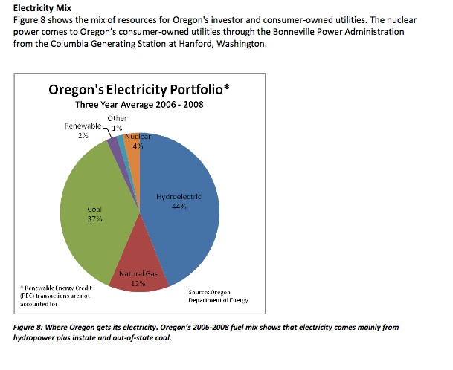

#### THE LEGACY OF COAL AND HYDROPOWER

Right now, Dragoon said, a lot of Oregon’s coal-fired power comes from plants in Wyoming and Montana – because that’s where the coal is, and that’s how the system was set up.

“It’s a historical legacy. We started out with lots of coal power,” he explained. “A lot of people are almost asking the opposite question. If we have all this traditional energy why are we using all these renewables?”

“Montana and North Dakota are the Saudi Arabia of wind, but they’re very far away, and the transmission lines are full of coal.”                                      — Ken Dragoon, Northwest Power Council

Wind energy is newer, and it’s been developed largely in response to renewable energy mandates in California, Oregon and Washington. Wind is the cheapest and quickest renewable energy source to develop, said Shimshak. And California, with the highest renewable energy goal in the country, has bought about half the wind energy developed in Oregon since 1998. The [world’s largest wind farm](http://ecotrope.opb.org/2011/04/oregons-shepherds-flat-wind-farm-big-enough-to-split-five-ways/) is being built in Oregon, but all its power under contract to go to California.

And as for hydropower, there’s a lot of it flooding the Northwest power grid now, Dragoon said, “but come August, the river will dry up and it’ll be back to being about half the power.” Coal and natural gas plants that are[dialed down now](http://ecotrope.opb.org/2011/05/here-now-all-renewable-electricity/) will be dialed back up as needed, and [depending on the price of power](http://ecotrope.opb.org/2010/11/energy-trade-offs-why-were-still-burning-coal/).

Because hydropower has always peaked in the spring, when the Northwest[doesn’t need that much power](http://ecotrope.opb.org/2011/05/bpa-we-have-all-this-power-and-nobody-wants-it/), there’s a lot of transmission already tying the Northwest and California together. In fact, the Northwest exported hydropower to California long before any wind farms were built.

Combine those forces with the individual utilities’ purchasing decisions, and you get power from fossil-fuels coming into the state while renewable power flows south to California.

#### CHANGE IN THE WIND?

Dragoon says the traditional power dynamics are changing, though.

A [new California law](http://gov.ca.gov/news.php?id=16974) limits the amount of renewable energy the state can import from other states, which will affect the amount of renewable energy Oregon exports to its southern neighbor.

“They’re beginning to prefer solar power,” Dragoon said of California. “They are definitely looking for new sources of energy, but the amount of import is limited by the law. It sounds as though their interest in acquiring more renewables from the Northwest is limited.”

Oregon’s one coal plant, in Boardman, is [due to close in 2020](http://ecotrope.opb.org/2010/12/commission-approves-boardman-2020-closure/). That won’t stop coal-fired power from flooding into Oregon from Wyoming and Montana.

“The great wind resource in the Columbia River Gorge is exactly the opposite as the wind we have in central Montana. This is the holy grail of wind.”                         — Montana Gov. Brian Schweitzer

But Dragoon said other factors might: [New regulations](http://www2.tricities.com/business/2011/may/25/wood-gives-dire-warning-due-epa-regulations-coal-f-ar-1062322/) from the Environmental Protection Agency and new renewable power sources from “the [Saudi Arabia of wind](http://www.nrel.gov/wind/systemsintegration/images/home_usmap.jpg).”

New emission rules are raising the cost of operating coal plants, which is part of the reason the only coal plants in Oregon and [Washington](http://www.triplepundit.com/2011/05/washington-state-closes-door-coal-opens-new-opportunities/comment-page-1/) are scheduled to shut down by 2025.

If other coal plants follow suit, Dragoon said, the coal-fired power that comes from Montana and Wyoming into Oregon could be replaced by wind power that peaks at different times from the wind power in the Northwest.

“Things are shifting around and changing a whole bunch,” said Dragoon. “If we end up changing out coal plants in Montana and Wyoming, it might open up transmission lines for wind to come into the Northwest. Montana and North Dakota are the Saudi Arabia of wind, but they’re very far away, and the transmission lines are full of coal.”

In fact, Montana Gov. Brian Schweitzer suggested something along those lines at a wind energy conference in California last week.

“What we now know is the great wind resource in the Columbia River Gorge is exactly the opposite as the wind we have in central Montana,” Schweitzer said. “We have a transmission line that ties the two together – the wind that blows during the day and wind that peaks during the night. Our wind peaks at one time of the year. Their wind peaks at other time of the year. This is the holy grail of wind. We can burn wind on wind 75 percent of the time.”